Quarch Technology Ltd

AN-012

Application Note

QIS Python control of power modules

For use with:

**Original Power Modules  
XLC Power Modules  
HD Power Modules**

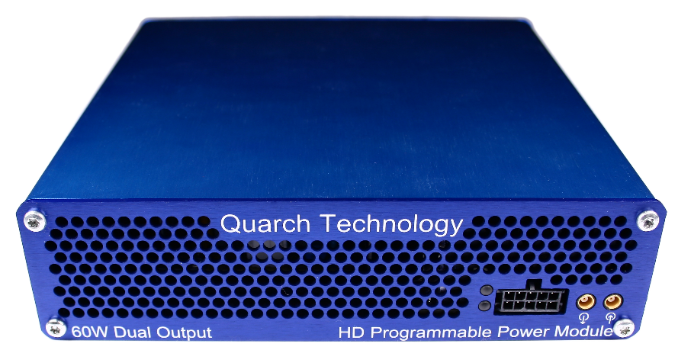

# Change History

|  |  |  |
| --- | --- | --- |
| -01 | Dec 2016 | Initial Release |
| -02 | Feb 2017 | Improved documentation |

Contents

Change History 2

Introduction 4

Modules Supported 6

Installation and setup 7

Linux setup 7

Windows setup 10

Provided Examples 12

Locating devices 12

Streaming capture example 13

QIS built in terminal 14

QIS remote terminal control 17

Customer support from Quarch 19

Access support from the Quarch website 19

Find discussion topics, support information and testing ideas. 19

# Introduction

Quarch Programmable Power Modules (PPMs) can be controlled using QIS (the Quarch Instrumentation Server). This is a simple Java server application which runs in the background and allows simple control of Quarch modules.

While these modules can be controlled via pure python (AN-004 application note), there are advantages to using QIS:

* No additional library installs are required (other than Java)
* Power modules can stream at far higher rates with QIS than with pure python
* QIS hides much of the complexity of binary data transfer from power modules
* QIS can be controlled from any language (via TCP port), so use is not restricted to Python
* QIS can use multiple devices at the same time, across different interfaces
* QIS can locate remove LAN devices without knowing their IP or name (using a TCP broadcast packet)

QIS runs on any Windows/Linux host PC. A USB cable or network connection to the Quarch power module allows QIS to control it.

The automated scripts that control QIS can now be run on the Host PC, or on any other PC on the network. While this application note demonstrates the use of Python, any language can be used to connect to QIS over TCP and issue commands.

QIS

Customer Drive

USB/LAN Connection

Power Module

Customer Host PC

# Modules Supported

Original power modules:

* QTL1455
* QTL1658
* QTL1730
* QTL1727

XLC power modules

* QTL1824 (QTL1824-02A modules do NOT support streaming, but can be upgraded by Quarch)
* QTL1847

HD power modules

* QTL1995
* QTL1999

All standard Quarch modules and controllers are also supported by QIS, though this note is specifically looking at control of power modules.

# Installation and setup

## Linux setup

This setup was based on Ubuntu Linux and a clean install. Changes may be needed for other systems. You may require admin access for the install.

* 1. Copy the application note files to a folder on your Linux system
  2. Check Java is installed:

Open a terminal window

>java -version

If the command fails, you will need to install the appropriate version of the Java JRE on your system.

You can find install instructions and files here:  
<http://www.oracle.com/technetwork/java/javase/downloads/index.html>

* 1. Run QIS

QIS is found in the /QIS folder of the application note. Simple double click QIS.jar to run it

QIS can also be invoked from the command line:

>java –jar qis.jar

For systems without a GUI environment, you can disable all graphical components, allowing the server to run on basic systems.

>java –Djava.awt.headless=true –jar qis.jar

If running QIS from a terminal window or script, you will likely find that closing the window will terminate QIS, you can prevent this from happening by using a combination of ‘nohup’ and ‘&’ on the command:

>nohup java –jar qis.jar &

Unless you have used the ‘headless’ option, you should now see a small Quarch icon in the task bar, representing QIS. Right clicking on this gives options to exit or to display a manual control terminal for typing commands.

Default USB permissions on Ubuntu may require ‘sudo’ to run QIS, or it will not have access to USB. This can be avoided by setting explicit permissions for Quarch USB devices.

Create a text file called Quarch-Permissions-USB.rules

Into the file, enter the text:

SUBSYSTEM==”usb”,ATTRS{idVendor}==”16d0”,MODE=”0666”  
 SUBSYSTEM==”usb_device”,ATTRS{idVendor}==”16d0”,MODE=”0666”

Save the file and close it

On the command line, copy it into the rules folder:

>**sudo cp** Quarch-Permissions-USB.rules /etc/udev/rules.d

You will need to reset for this to take effect

* 1. Run the list devices script, to check which modules are available to you

>python QisListDevices.py

Below we can see that three devices were found, one local XLC module on USB and two remote devices on LAN.

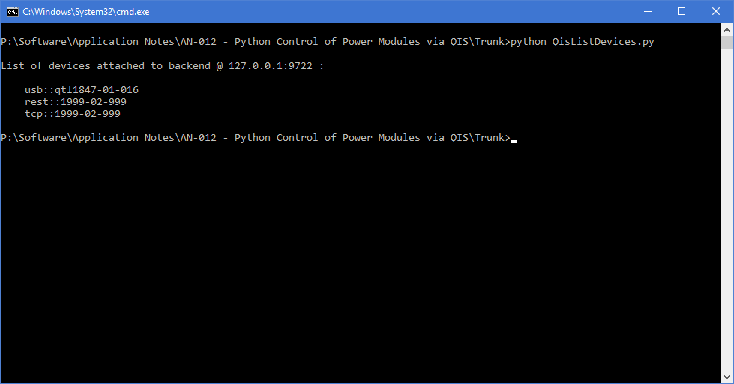

If you have not run QIS before running the script, you instead will see:

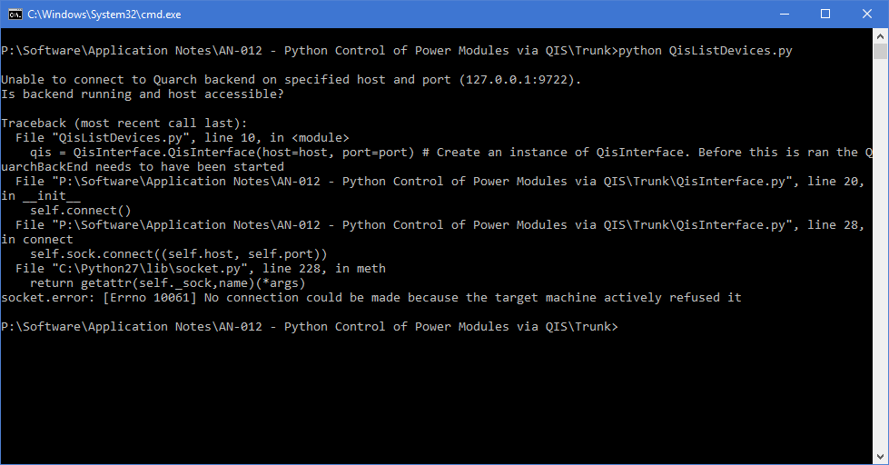

* 1. You are now fully ready to run the main examples

## Windows setup

This setup was based on Windows 10 and a clean install. Changes may be needed for other systems. You may require admin access for the install.

* 1. Copy the application note files to a folder on your system
  2. Download and install the Quarch USB driver from:

<http://quarch.com/downloads?field_file_type_tid=113>

* 1. Check that the Java JRE is installed

You can find install instructions and files here:  
<http://www.oracle.com/technetwork/java/javase/downloads/index.html>

* 1. Run QIS

QIS is found in the /QIS folder of the application note. Simple double click QIS.jar to run it

QIS can also be invoked from the command line:

>java –jar qis.jar

For systems without a GUI environment, you can disable all graphical components, allowing the server to run on basic systems.

>java –Djava.awt.headless=true –jar qis.jar

Unless you have used the ‘headless’ option, you should now see a small Quarch icon in the task bar, representing QIS. Right clicking on this gives options to exit or to display a manual control terminal for typing commands.

* 1. Run the list devices script, to check which modules are available to you

>python QisListDevices.py

Below we can see that three devices were found, one local XLC module on USB and two remote devices on LAN.



If you have not run QIS before running the script, you instead will see:



* 1. You are now fully ready to run the main examples

# Provided Examples

## Locating devices

The file QisListDevices.py contains a simple example, querying QIS to get a list of available devices. This lets us see what is available, and conform that everything is working.

The name format will be used later for choosing the module to use. For example:

usb::qtl1847-01-016

This represents a USB connection to a QTL1847 (XLC Power Module), with a serial number of QTL1847-01-016

>python **QisListDevices**.py



## Streaming capture example

The file QisStreamExample.py connects to a selected module and runs a number of commands to prepare for streaming capture of data.

‘Streaming’ involves the PC client software constantly puling data back from the Quarch module. This allows for much longer recording times that when using the internal RAM on the module. The lower the averaging rate, the faster that data must be read back to keep up. XLC modules can generally stream at 16 sample averaging with a fast PC. HD modules can generally get to 4 sample averaging.

QIS holds a large data buffer, and will keep pulling data back from the module when the Python script is busy. This allows you to perform additional tasks, such as invoking an IO transfer to the device you are testing.

This example is set to a far higher value initially so as to produce a small and simple CSV file.

The script sets up the module and then begins streaming for a set period of time. When complete a CVS file will have been created, for later viewing and processing.

>python QisStreamExample.py

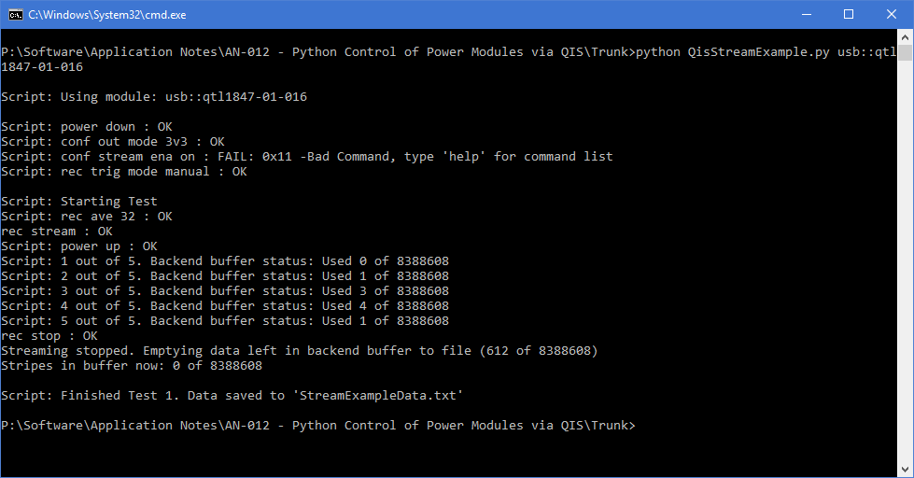

The output the commands that we ran (and their responses). It also shows the statistics on the data that we pulled back from the module.

# Debugging

There are a number of built in options for debugging QIS and Python scripts, allowing you to track down problems

* The simple script to ‘locate devices’ (described above) checks that QIS is running and accessible, without needing a device attached
* QIS has a built in terminal which can be used to check access to devices, without needing to run a script
* A remote terminal (putty for example) can be used to check access to a QIS server, allowing you to check it is accessible needing access to Python

## QIS built in terminal

QIS has a built in Terminal. When running, there will be an icon in the task bar. Right click this and select ‘Show Terminal’. If the icon does not work on your linux distro, run QIS with the –terminal option

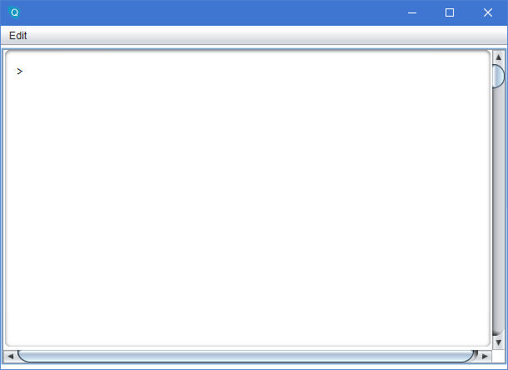

To get a list of commands enter:

>$help

To get a list of available modules enter:

>$list

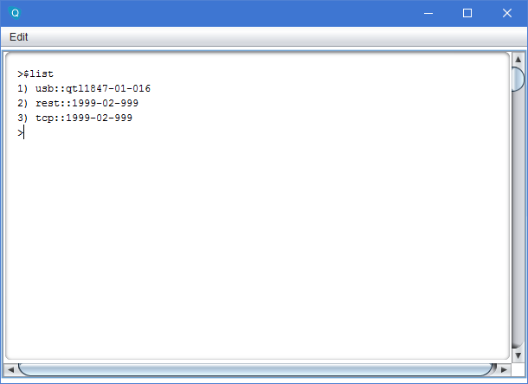

To select a device to control (We want the USB device in this case), use the command:

>$default 1

You can now enter any standard command for the chosen device (see the device technical manual for command lists).

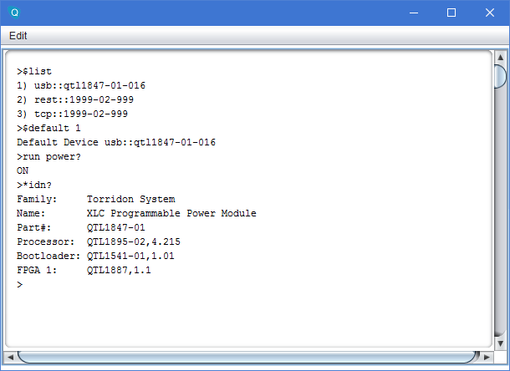

## QIS remote terminal control

QIS works by exposing a TCP port on the PC it runs on. You can connect to this via a standard terminal program such as Putty. Below you can see the setting used.

The IP address is the IP of the PC running QIS  
The port is 9722  
The connection type must be ‘Raw’

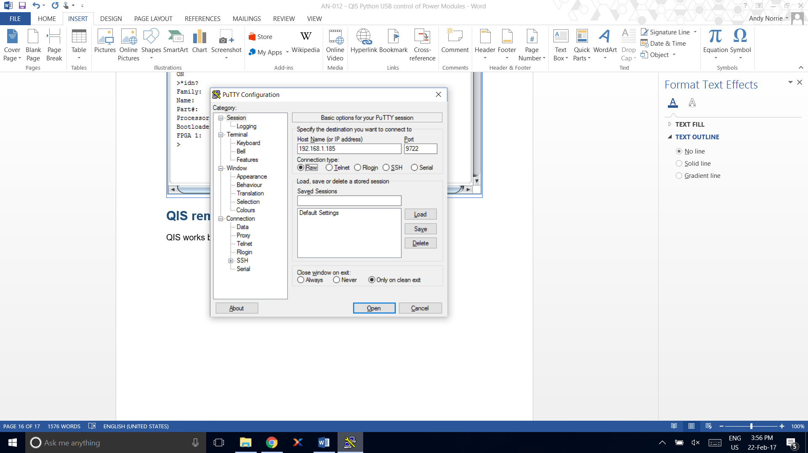

When connected, you can use the same commands as were described in the ‘QIS built in terminal’ section.

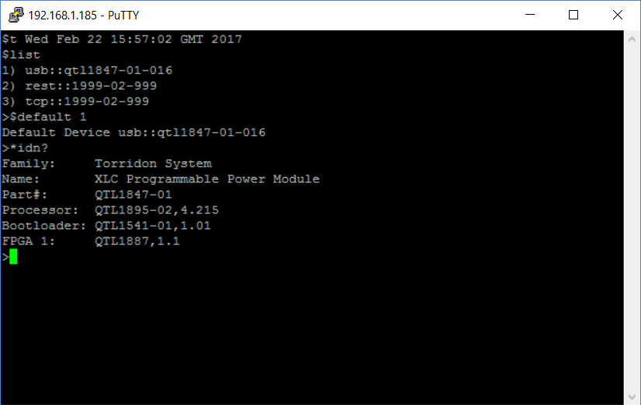

## Know Issues

* CentOS 7 with Gnome:

Running QIS will show an icon for the server application, but it cannot be right-clicked to get to the menu.

To use the terminal, it must be invoked with:   
java –jar qis.jar –terminal

When the terminal is running, the icon on the task bar is over sized, but is functional. If the terminal is closed, you will not be able to open it again.

As the taskbar icon does not work, you may have to terminate the QIS process manually.

# Customer support from Quarch

There are multiple ways to access the support you need. You can contact us directly or access an extensive range of valuable support materials from <http://quarch.com/support>.

* Contact us direct
* Get going quickly and easily, with help direct from the engineers:
* Call +44 1343 508 140 or email [support@quarch.com](mailto:support@quarch.com) during UK office hours.
* Our international partners are well trained in the use of our products and can deal with many basic technical queries from within your time zone, if you prefer. Check <http://quarch.com/resellers> for the contact details of your regional supplier.

## Access support from the Quarch website

You can download up-to-date software and drivers, technical manuals, datasheets and more from our website. To help you get started quickly we provide additional documents, such as examples in Perl, Python and C# and Telnet and Serial instructions.

* Key **places to visit on** the Quarch website
* Register your Quarch product to confirm your international warranty: <http://quarch.com/product-registration>
* Download a wide range of documentation, free applications and drivers to help you make the best possible use of your Quarch tools: <http://quarch.com/content/downloads>
* Access the Quarch support forum (<http://quarch.com/forum>):

## Find discussion topics, support information and testing ideas.

Browse existing topics or login to your user account to ask for information and advice.

Sign up for Quarch Technical Updates to get the most out of your Quarch products. Updates are published approximately once a quarter and include news about the latest features, tools, application notes and software updates. See <http://quarch.com/content/sign-quarch-technical-updates>.